Software Requirement Specifications
AutoHub
An AI-Powered Car Discovery and Management Platform



Submitted by
M. Farrukh Javaid
Roll No:
F22BINFT1M01279
Submitted to
Ms. Kainat

Department of Information Technology
Faculty of Computing
The Islamia University of Bahawalpur

Meeting Details
Sr No | Details | Date | Supervisor Signature
Summary
This document presents the Software Requirements Specification (SRS) for AutoHub – An AI-Powered Car Discovery and Management Platform. The project aims to modernize the car-buying experience by integrating artificial intelligence with a responsive and user-friendly web interface. AutoHub addresses the limitations of traditional car marketplaces by offering intelligent search capabilities, image-based car recognition, personalized recommendations, and an organized platform for managing bookings and vehicle information.
The document outlines the complete functional and non-functional requirements of the system, covering both customer-facing features—such as browsing cars, AI-powered search, test drive booking, and user dashboards—and administrator functionalities, including inventory management, booking control, analytics, and AI-driven image scanning. Additionally, the SRS defines the technologies used, system constraints, performance goals, and usability standards essential for building a scalable and secure platform.
Overall, this SRS provides a comprehensive foundation for the design and implementation of AutoHub, ensuring that all system components are clearly defined to guide development and support future enhancement.

Table of Contents
1. Introduction 6
1.1. Purpose 6
1.2. Scope 6
1.3. Product Perspective 6
1.4. Similar apps and systems/Literature Review 7
1.5. Proposed Technologies 7
2. Requirements 7
2.1. Function Requirements 7
2.1.1 Sign Up 7
2.1.2 AI-Powered Search 8
2.1.3 Image-Based Recognition 8
2.1.4 Test Drive Booking 8
2.1.5 Admin Inventory Management 8
2.2. Non-Functional Requirements 8
3. Use Cases and Flow of Processes 9
3.1. Use Case 11
4. References 12

- Introduction
  - Purpose

The purpose of this Software Requirement Specification (SRS) is to define the detailed functional and non-functional requirements of AutoHub – An AI-Powered Car Discovery and Management Platform. This document serves as a formal reference for developers, UI/UX designers, supervisors, testers, and stakeholders to understand system behavior, constraints, and components.
  - Scope
AutoHub focuses on the development of the following key system components:
✔ AI-powered car search
✔ Image-based car identification
✔ Car comparison and detail view
✔ Test drive booking and reservation system
✔ User authentication and dashboards
✔ Admin panel for car and user management
The following items are NOT included in this development:
✖ Online payment gateway
✖ Real-time price negotiation chat
✖ Mobile application

  - Product Perspective

AutoHub is a standalone, web-based software solution that connects buyers and dealerships on one platform. It integrates with Gemini AI APIs for intelligent search and image recognition and uses PostgreSQL for database management. The platform includes separate customer and admin panels.User Characteristics
User Type | Skills | Interaction
Customer | General internet user | Medium
Dealer/Admin | Basic computer skills | Medium
Super Admin | Technical awareness | High
  - Similar apps and systems/Literature Review
Platform | Features | Shortcomings
PakWheels | Listings, reviews | No AI search, no image recognition
OLX Autos | Buying/selling cars | Limited filtering and no admin analytics
CarGurus | Smart search | Not region-focused, no test drive booking
  - Proposed Technologies
Category | Proposed
Frontend | Next.js
Backend | Node.js
Database | PostgreSQL
Programming Language | TypeScript
AI Integration | Gemini AI API
UI Components | Shadcn UI
Security | Arcjet Protection
Deployment | Vercel

- Requirements
AutoHub will allow users to browse cars, perform intelligent searches, book test drives, and save preferences. Admin will manage inventory, users, bookings, and AI scan results through a secure dashboard.
  - Function Requirements

2.1.1 Sign Up
- Name: FR001
- Purpose: Register new users for platform access.
- User(s): Customer, Admin
- Input:
  - Name
  - Email
  - Password (minimum 8 characters, must include a number)
  - Phone number (11 digits)
  - City
- Output: Account created, requires email verification.

2.1.2 AI-Powered Search
- Name: FR002
- Purpose: Search cars using natural language queries.
- User(s): Customer
- Input: Text search such as “Hybrid car under 30 lac”.
- Output: Filtered results based on AI understanding.

2.1.3 Image-Based Recognition
- Name: FR003
- Purpose: Identify car model/type using image.
- User(s): Customer, Admin
- Input: Car image upload.
- Output: Recognized model and suggestions.

2.1.4 Test Drive Booking
- Name: FR004
- Purpose: Book a test drive from listings.
- User(s): Customer
- Input: Date, location, selected vehicle.
- Output: Booking confirmation.

2.1.5 Admin Inventory Management
- Name: FR005
- Purpose: Manage car listings.
- User(s): Admin
- Input: Car details (make, model, year, price).
- Output: Car added/updated/deleted.

  - Non-Functional Requirements
Type | Description
Security | Role-based authentication, encrypted passwords
Performance | Must handle 100 simultaneous searches
Usability | Simple UI for non-technical users
Reliability | 99% uptime
Compatibility | Supports Chrome, Firefox, Safari
Scalability | Database expandable to 30,000 listings

- Use Cases and Flow of Processes
Use cases are the formal representation of process flow defined by functional requirements. Authors should provide a flow of events in this. There should be system level use case which is directly influenced to project functions with their user(s) (called actor(s)) which are described in requirements chapters

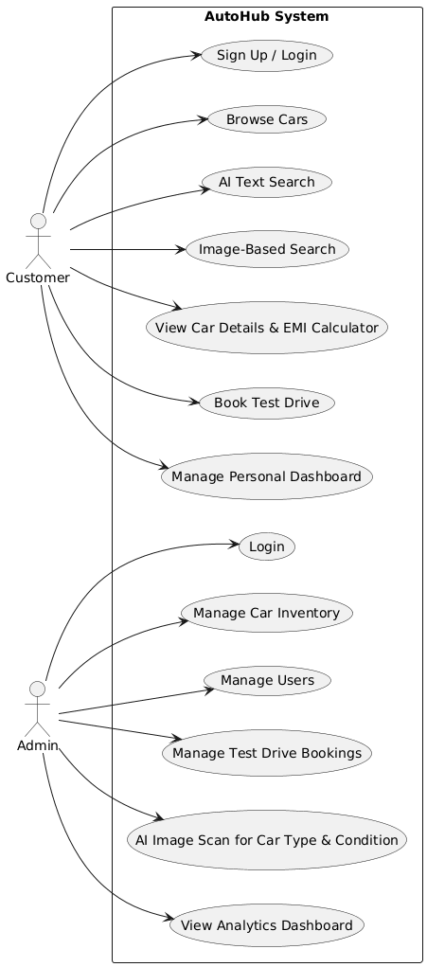
Figure 1: System Level Use Case Diagram

  - Use Case
ID | UC001
Name | Sign Up
Description | This use case describes the process flow of Sing Up
Requirement(s) | FR001
Actor(s) | Admin, Data Entry, Operator
Precondition | Actors must not be member of Hospital
Postcondition | Actors will view the message for approval from admin
Basic Flow | Basic Flow  - Actor enter credentials  - System validates the inputs  - Following fields are required  - Name  - Email  - Password  - Address  - Phone  - Check the proper inputs for following  - Email  - Password must be 8 character including number  - Phone Number on 11 digits  - On successful validation the system will create new user  Alternative Flow  - Admin Sign In  - Create a new User by entering data  Exceptions  - Invalid Inputs  - System unable to response
- References
- Next.js Documentation
- Gemini AI API Documentation
- PostgreSQL Database Docs
- SRS IEEE Template Standards

